1. DHCP
   1. Definition: DHCP (Dynamic Host Configuration Protocol) is a way to send configuration information to hosts on a network. For use in this project the DHCP server in a router is given a range of ip addresses and assigns them dynamically when requested. This saves having to give the end pcs static ips and allows for ips to be reused after being inactive.
   2. 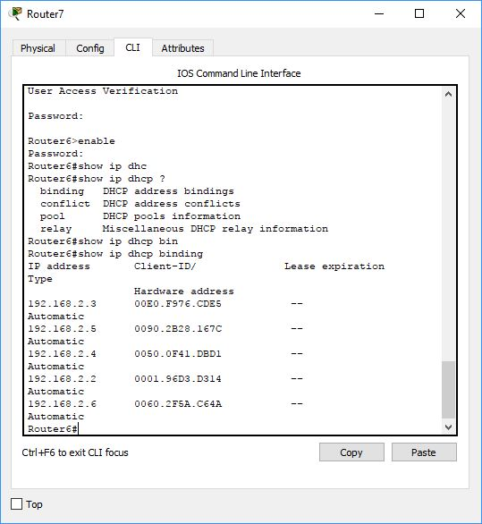Screenshot of the current DHCP bindings for Router7:
2. IPv4 Internal Routing Protocol
   1. Definition: EIGRP (Enhanced Interior Gateway Routing Protocol) is an internal routing protocol used to send information on known routable networks to other routers in said network. This saves us from having to statically route all the networks in our topology. Because EIGRP dynamically updates, if a connection to a neighbor were to go down a new route could be found.

Resource:

“Enhanced Interior Gateway Routing Protocol.” Cisco, 5 Sept. 2017, www.cisco.com/c/en/us/support/docs/ip/enhanced-interior-gateway-routing-protocol-eigrp/16406-eigrp-toc.html.

* 1. Screenshot of learned networks through EIGRP on Router3:

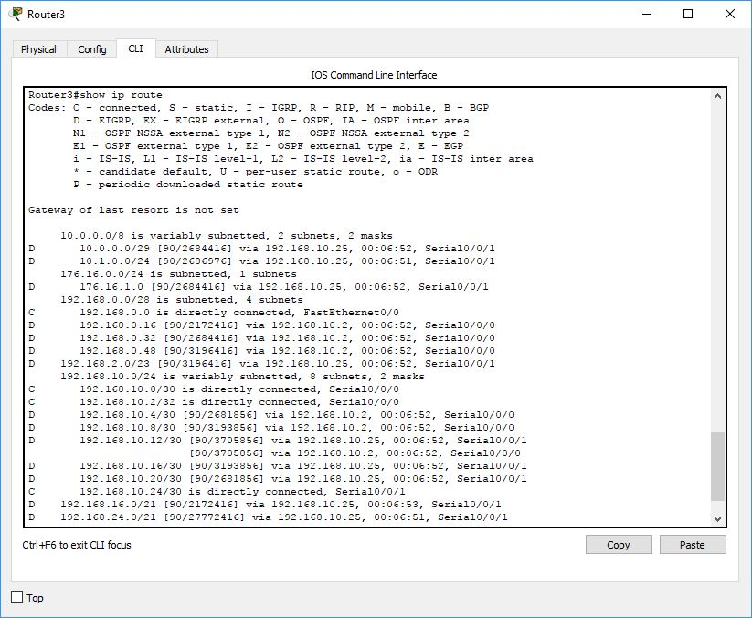

1. Link Aggregation
   1. Definition: Link Aggregation is the bundling of multiple links between Switches. This allows not only for higher throughput by sharing the load between the links, but also provides redundancy in case one of the links was to go down.
   2. Screenshot of the EtherChannel summary of Switch7-0 connected to Switch7-1:

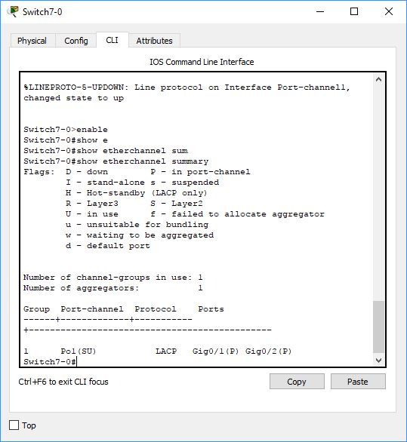

1. IPv6 Internal Routing Protocol
   1. Definition: Once again using EIGRP an internal routing protocol used to send information on known routable networks to other routers in said network, we are able to dynamically get route information. This time though it is for IPv6 addresses.
   2. Screenshot of learned EIGRP route in Router4:

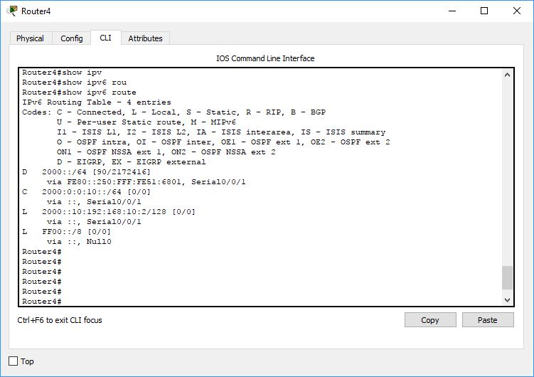

1. PPP with CHAP
   1. Definition: PPP is a method of encapsulation for data being transported through connected serial ports on two routers. CHAP one of the authentication methods useable by PPP. CHAP is more secure than the default PAP because it sends a hashed password not the password itself.

Resource:

“Software Configuration Guide - Configuring PPP.” Cisco, 11 July 2017, www.cisco.com/c/en/us/td/docs/routers/connectedgrid/cgr1000/1_0/software/configuration/guide/scada/scada1/sca_ppp_cgr1000.html.

* 1. Screenshot:

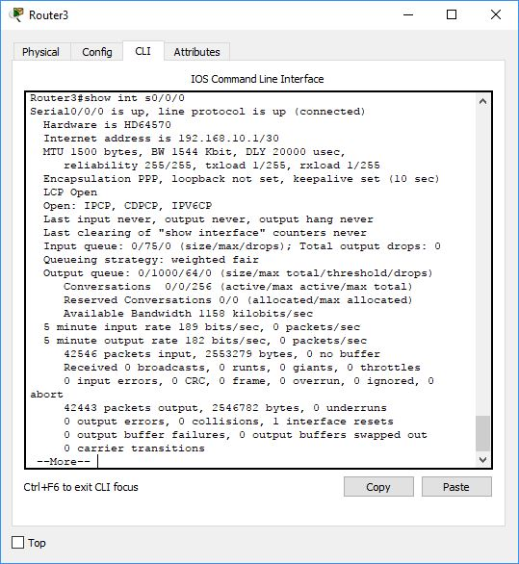

1. Vlan
   1. Definition: A Vlan is a virtual way to partition a larger lan into smaller more targeted lans. It also allows devices not on the same physical lan to communicate as though they were, given they are set in the same Vlan. It also works to segment a network. This could be beneficial as an added layer of security, say if you wanted the finance department separate from everyone else.
   2. Screenshot of the Vlans in HQ’s Core1:

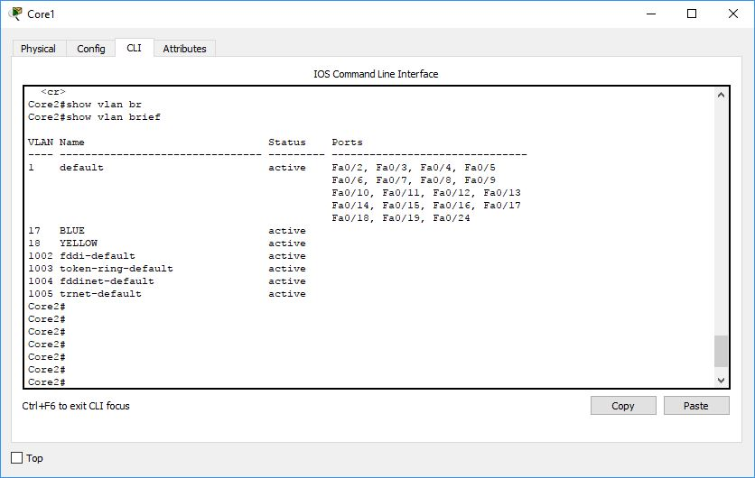

1. VTP
   1. Definition: VTP is a way to configure Vlans on one device then have those changes take affect across the entire VTP domain. After setting up a VTP domain, password, and server all Vlan information will be distributed from that server. If you add a switch in client mode to your domain it will acquire all its Vlan information from the VTP server. This means Vlan information only needs editing on one device reducing the chance of making errors.
   2. Screenshot of HQ Core1 set up as VTP server for the HQ:

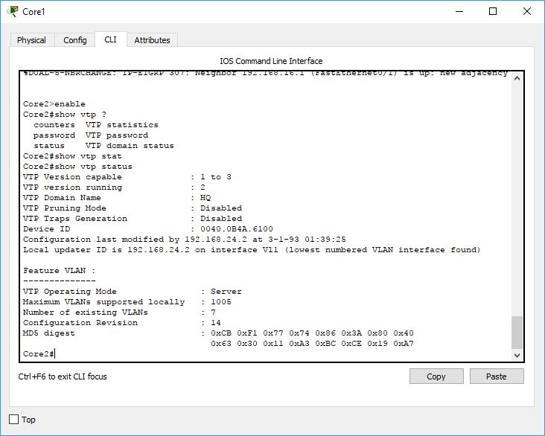

1. Inter-Vlan Routing
   1. Definition: Inter-Vlan Routing is the routing of packets from one Vlan to another. Normally devices on one Vlan would be unable to reach devices on a separate Vlan. PCs in HQ’s BLUE Vlan are able to reach pcs in its YELLOW Vlan thanks to inter-Vlan routing done by HQRouter2.
   2. 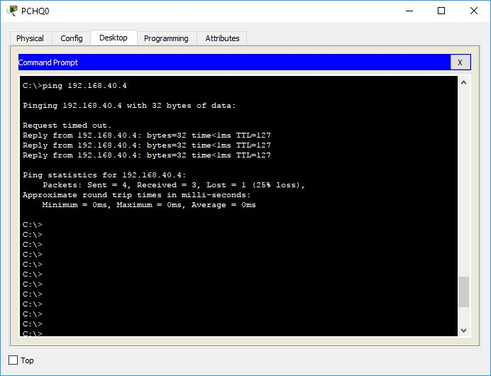Screenshot of PCHQ0 (Vlan 17) pinging PCHQ1 (Vlan18):
2. Static NAT
   1. Definition: Static NAT (Network Address Translation) is a way of translating from an external address to an internal one. This allows you to hide the internal addressing scheme. It also means if your external address was ever to change (move location or change ISP) you would not have to redo your entire internal scheme.
   2. Screenshot of the static NAT for HQ’s HTTP server:

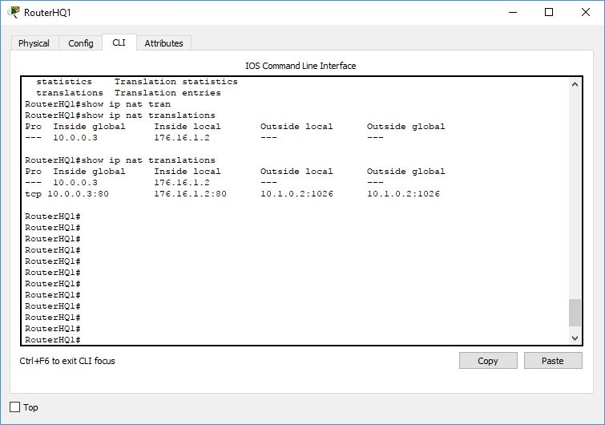

1. Dynamic NAT/PAT
   1. Definition: Dynamic NAT works the same as static NAT, other than it allows you to bind multiple internal ip addresses to one or more external ip addresses. Where static NAT was one to one dynamic NAT is one to many or many to many. This allows multiple internal pcs to be bound to just a few external ips.
   2. Screenshot of HQ’s Router1 Dynamic NAT:

